HASAD
Smart Farming System

Final Project Report Submitted to
The Department of Computer Science
Faculty of Computer and Information Technology
Jordan University of Science and Technology

In Partial Fulfillment of the Requirements for the Degree of
Bachelors of Science in

Artificial intelligence

By

Zeid Sabri AlSuleiman (166203)
AlKhattab Fawaz AlSafsfh (164894)
Mohanad Abdulsalam Bataineh (162015)
Abdulraheem Musa Al-Natour (160324)
Hakem Bilal Khasawneh (160720)

Fall/Spring/Summer year

نموذج حقوق الملكية الفكرية لمشاريع التخرج في قسم علوم الحاسوب

يتم قراءة وتوقيع هذا النموذج من قبل الطلاب المسجلين لمشاريع التخرج في قسم علوم الحاسوب
تعود حقوق الملكية الفكرية لمشاريع التخرج ونتائجها (مثل براءات الاختراع أو أي منتج قابل للتسويق) إلى جامعة العلوم والتكنولوجيا الأردنية، وتخضع هذه الحقوق إلى قوانين وأنظمة و تعليمات الجامعة المتعلقة بالملكية الفكرية وبراءات الاختراع.
بناءا على ما سبق أوافق على ما يلي:
- أن أحفظ كافة حقوق الملكية الفكرية لجامعة العلوم والتكنولوجيا الأردنية في مشروع التخرج.
- أن ألتزم بوضع اسم جامعة العلوم والتكنولوجيا الأردنية و أسماء جميع الباحثين المشاركين في المشروع على أي نشرة علمية للمشروع كاملا أو لنتائجه. و يشمل ذلك النشر في المجلات و المؤتمرات العلمية عامة أو النشر على المواقع الإلكترونية أو براءات الاختراع أو المسابقات العلمية.
- أن ألتزم بأسس حقوق التأليف المعتمدة في جامعة العلوم والتكنولوجيا الأردنية.
- أن أقوم بإعلام الجهة المختصة في الجامعة عن أي اختراع أو اكتشاف قد ينتج عن هذا المشروع و أن ألتزم السرية التامة في ذلك و أن أعمل من خلال الجامعة على الحصول على براءة الاختراع التي قد تنتج عن هذا المشروع.
- أن تكون جامعة العلوم والتكنولوجيا الأردنية هي المالك لأي براءة اختراع قد تنتج عن هذا المشروع و تشمل هذه الملكية حق الجامعة في إعطاء التراخيص و التسويق و البيع كمؤسسة راعية و داعمة لكافة الأنشطة البحثية. و يكون حق للطالب شمول اسمه على براءة الاختراع كأحد المخترعين، و في حال تم إعطاء تراخيص أو تسويق و بيع لأي من منتجات المشروع يمنح المخترعون بما فيهم الطالب نسبة من الإيرادات حسب تعليمات البحث العلمي في جامعة العلوم والتكنولوجيا الأردنية.

اسم الطالب التوقيع اسم الطالب التوقيع
اسم الطالب التوقيع
اسم الطالب التوقيع
اسم المشرف التوقيع
تاريخ ................................
DEDICATIONS
We dedicate our work to our families, who were the backbones of our lives and the most supportive on this path, Thank you for your constant prayers and trust throughout this journey.
To our supervisor, Dr. Suleiman Bani Ahmad, a truly kind and supportive man, who was always there for us. Thank you for guiding us whenever we felt lost or needed anything.
To the faculty members of the Computer Science Department, we thank you from the bottom of our hearts for everything you have given us during this academic journey.
To our friends and colleagues who supported us through these long nights and difficult times. This project would not have been possible without you.

Finally, we are grateful to everyone who supported us throughout this work.

DECLARATIONS
We declare that the “HASAD System” project is done by our group, without using any non-mentioned sources and all the used sources is mentioned in the references.
We also ensure that this report has not been submitted previously to Jordan University of Science and technology or any other university for any degree or other qualification.
We acknowledge that plagiarism and fraud are serious illegal acts, we accept full responsibility for the content of this report.

ACKNOWLEDGEMENTS
First, we are thankful to Allah for giving us the strength and the ability to accomplish this work.
We are grateful to DR. Suleiman Bani Ahmad, our supervisor who guided and supported us through this project, as well as his feedbacks which was very important to achieve what we achieved today.
We also indebted to the head of the Computer Science Department at Jordan University of Science and Technology Dr. Mohammad Alzubi and the entire Department for providing a supportive academic environment.

ABSTRACT
The agriculture sector in Jordan plays a big role in the economy, but it faces major challenges here due to water scarcity and unstable weather conditions, Although precision agriculture is becoming widely used, many farmers in Jordan can not afford smart farming solutions like hardware and sensors, so here come our project “HASAD System”, smart farming system that uses software and machine learning that provide a similar results to the hardware-based systems but with a much lower cost.
The system provides a solution for improving irrigation efficiency, supporting early disease detection and offers an AI assistant that provide localized recommendation.
TABLE OF CONTENTS
PAGE
DEDICATIONs III
DECLARATIONS IV
ACKNOWLEDGEMENTS V
ABSTRACT VI
LIST OF TABLES IX
LIST OF FIGURES X
ABBREVIATIONS XI

CHAPTER
1. INTRODUCTION 1
1.1 Motivation 1
1.2 Problem Statement 1
1.3 Summary of Functionalities 1
1.4 Summary of Results 2
2. REVIEW OF RELATED LITERATURE 3
2.1 Theoretical Background 3
2.1.1 Evapotranspiration Modeling 3
2.1.2 Crop Specific Adjustment 3
2.1.3 Soil Water Balance 4
2.1.4 Ensemble Learning for Disease Prediction 4
2.1.5 Retrieval Augmented Generation 4
2.2 Related Systems 4
2.2.1 Wafirr System 5
2.2.2 Plantix System 5
2.2.3 Irri-Smart System 5
2.2.4 Farmonaut System 5
2.2.5 Irey System 5
2.3 Summary of Related Works 6
3. ANALYSIS AND DESIGN 7
3.1 Requirements Analysis 7
3.1.1 Functional Requirements 7
3.1.2 Non-Functional Requirement 7
3.2 Risk Assessment 8
3.3 System Architecture 9
3.4 User Experience and User Interface 13
4. IMPLEMENTATION 15
4.1 System Implementation Overview 15
4.2 Backend Implementation 15
4.3 Frontend Implementation 15
4.4 Version Control and Deployment 15
5. TESTING AND EVALUATION 16
5.1 Functional Requirement Testing 16
5.2 Non-Functional Requirement Testing 16
5.3 GitHub Actions Workflows 16
5.4 Results and Discussion 17
5.5 Summary 17
6. CONCLUSION 18
6.1 Key Findings and Results 18
6.2 Strengths of the HASAD System 18
6.3 Limitations of the Project 18
6.4 Future Work 19
6.5 Summary 19
REFERENCES 20
APPENDIX 21

LIST OF TABLES
TABLE PAGE
2.1 Existing systems key features and limitations 6

3.1 Functional Requirements 7
3.2 Non-Functional Requirements 8
3.3 Systems Risks 8

LIST OF FIGURES
FIGURE PAGE
3.1 High-Level Structure diagram 9
3.2 Use Case Diagram 10
3.3 ER Diagram 11
3.4 Sequence Diagram 12
3.5 SignIn\ SignUp User Interface. 13
3.6 Dashboard User Interface 13
3.7 Farms Management User Interface 14
3.8 Farm Configuration User Interface 14

ABBREVIATIONS

Abbreviation | Definition
ER | Entity Relationship
ET0 | Reference Evapotranspiration
ETc | Crop Evapotranspiration
FAO | Food and Agriculture Organization
FC | Field Capacity
FR | Functional Requirement
FK | Foreign Key
HTTPS | Hypertext Transfer Protocol Secure
INGC | National Field Crops Institute
IREY | Irrigation Reference to Enhance Yield
JWT | JSON Web Token
Kc | Crop Coefficient
NARC | National Center for Agricultural Research
NFR | Non-Functional Requirement
OAuth2 | Open Authorization 2.0
PWP | Permanent Wilting Point
RAG | Retrieval-Augmented Generation
RBAC | Role-Based Access Control
REST | Representational State Transfer
TAW | Total Available Water
TLS | Transport Layer Security
UI | User Interface
UX | User Experience
WAFIRR | Water For Irrigation
WaPOR | Water Productivity through Open access of Remotely sensed derived data

CHAPTER 1
introduction
This part is talking about "HASAD" system, a smart agricultural website developed to adapt Jordanian agriculture with cost-effective software solutions. This part highlights the project's background and motivations solving the problem of water scarcity and climate challenges after that focuses on problems such as resource waste and delayed disease detection. At the end, this part summarizes the system's main functions, including predictive irrigation and AI-powered agricultural suggestions, and briefly presents the main findings of this project.
  - Motivation
The agriculture in Jordan is the most important sector in Jordan’s economy, this sector is facing huge challenges due to Jordan water scarcity and unstable climate patterns, while the world going to smart agriculture Jordan lacks to this smart agriculture because of the low budget of the local farmers in Jordan, the smart agriculture tools typically require highly cost sensors and hardware, so our system solved this problem with meteorological data, and machine learning (software sensors), this method can give the farmer the same accuracy or more higher accuracy with extreme low cost than the hardware sensors.
  - Problem Statement
Jordan's current agricultural production methods rely heavily on guesswork and rigid, outdated irrigation systems. This has led to two key problems:
- Water resource waste: Over-irrigation wastes limited water resources and increases economic costs.
- Prevention after disease occurs because of the lack of forecasting equipment, farmers often discover diseases after crops have already been damaged, resulting in reduced production. General weather forecasts do not provide the precise location information needed to address these problems.

  - Summary of Functionalities
Hasad system solved the challenges we talked about in the previous part through these three smart modules:
- Predictive Irrigation Engine: precisely calculates crop water needs using meteorological data, solving the problem of needing soil sensors.
- ML-Powered Disease Risk Advisor: Analyzes environmental factors using machine learning and predicts diseases before they occur.
- RAG Enhanced AI Assistant: A customized chat interface that uses natural language processing to provide farmers with immediate, localized agricultural advice.

  - Summary of Results
The outcome is a fully functional online platform that gives instant alerts and precise suggestions. This system clarifies that data-driven software (software sensor) is an excellent and cost-effective alternative to hardware, helping farmers to save water, protect land from pests and diseases, and improve profitability.

CHAPTER 2
REVIEW OF RELATED LITERATURE
This chapter will discuss the scientific background of the HASAD platform. First, it explores the theoretical background of agricultural water modeling and machine learning classification. Then, it reviews five existing systems to identify the current technological gaps in the Jordanian agricultural market, and that shows the importance of Hasad as a software driven, low cost solution.
  - Theoretical Background
The core of the "Hasad" platform lies in its virtual sensing framework. This system replaces physical devices with mature agricultural principles and machine learning techniques, thereby providing a high precision, low cost decision support system.

    - Evapotranspiration Modeling (FAO-56)
To accurately calculate irrigation demand $ET_{c}$without using soil sensors, Hasad employed the FAO Penman-Monteith equation, a global standard for estimating soil evaporation and crop transpiration water depth. [1]
The Reference Evapotranspiration $ET_{0}$ Formula:

$$ET_{0}=\frac{0.408∆\left(R_{n}-G\right)+ γ\frac{900}{T+273} u_{2 }(e_{s}-e_{a})}{∆+ γ(1+0.34u_{2})} (EQ. 2.1.1)$$
Where:
- $∆$: Slope of saturation vapor pressure curve.
- $R_{n}$: Net radiation at the crop surface.
- $T$: Mean daily air temperature at 2m height.
- $u_{2}$: Wind speed at 2m height.
- $e_{s}-e_{a}$: Vapor pressure deficit.
- $G$: Soil heat flux density.
    - Crop-Specific Adjustment ($K_{c}$)
Because different crops (e.g., tomatoes and olives) have different water usage rates, the system applies a crop coefficient. ($K_{c}$). [1]
$$ET_{c}=ET_{0}×Kc (EQ. 2.1)$$
Hasad automates the process by mapping the user's selected crop type and growth stage to the corresponding $K_{c}$ value, thus ensuring that recommendations are tailored to specific plants.
    - Soil Water Balance & TAW
The system uses the Total Available Water (TAW) to know the soil's storage capacity before reaching the wilting point. [2]
$$TAW=1000\left(FC-PWP\right)×Z_{r} (EQ. 2.2)$$
- $FC$: Field Capacity (max water retention).
- $PWP$: Permanent Wilting Point (plant death threshold).
- $Z_{r}$: Rooting depth.

    - Ensemble Learning for Disease Prediction
While simple rules (e.g., "Humidity > 90%") provide a baseline, Hasad uses Random Forest Classification to get highest predictive accuracy. [3]
- Motivation: Random forest models are more effective than static threshold rules in handling the nonlinear relationship between weather variables and disease outbreaks.
- Logic: The system will look at past patterns of "leaf wetting time" and temperature changes to give a probability of risk (low, medium, high). [4]
    - Retrieval-Augmented Generation (RAG)
For giving expert advice by a smart chat assistant, the system uses a RAG architecture.
- Mechanism: rather than relying on "general AI" the system at the beginning retrieves contextual information from a dedicated vector database containing Jordanian agricultural guidelines before giving an answer. [5]
  - Related Systems
This section reviews five existing agricultural systems to identify current technology gaps in the Jordanian agricultural market. By analyzing the key features and limitations of platforms such as WAFIRR, Plantix, and Farmonaut, this review highlights the necessity of Hasad as a low cost, software driven solution designed to address the shortcomings of existing tools.

    - WAFIRR (National Center for Agricultural Research - Jordan)
WAFIRR (Irrigation Water) is Jordan's most direct local competitor, developed in cooperation with the National Research Centre for Agricultural Research (NARC) of Jordan and the Food and Agriculture Organization of the United Nations (FAO). [6]
- Key Features: It uses satellite data (WaPOR) to calculate evapotranspiration and rainfall to provide real-time irrigation advice for Jordanian farmers.
- Limitations: It focuses almost exclusively on water scheduling. It lacks the integrated Machine Learning disease prediction and the AI Chat Assistant that Hasad provides to give a holistic "doctor-like" experience for the farm.

    - Plantix (Global AI Diagnostic App)
it is the global leader in image-based agricultural AI. [7]
- Key Features: Uses Deep Learning and image recognition to identify over 120 plant pests and diseases from a single photo.
- Limitations: It is reactive, meaning the disease must already be visible on the leaf for the AI to find it. Hasad is proactive; our ML model predicts risk before the disease appears by analyzing weather patterns like high humidity "leaf wetness" hours.

    - Irri-Smart (Regional Decision Support Tool)
A mobile tool used in Morocco and other MENA regions for localized crop irrigation. [8]
- Key Features: Uses algorithms taking into account the Climate Soil Plant Water components to create daily irrigation programs.
- Limitations: It is primarily a Technical Decision Support Tool aimed at engineers and advanced farm managers. Hasads Ai Assistant simplifies this complex data for the "everyday" small-scale farmer who needs advice in simple, natural language.

    - Farmonaut (Satellite-Based Monitoring)
A platform that provides satellite-based crop health monitoring globally. [9]
- Key Features: Offers high-level satellite imagery to monitor field stress, soil moisture, and weather forecasts.
- Limitations: While it provides "satellite-based" soil moisture reports, these reports are often too coarse (too broad) for small 5 acre farms in the Jordan Valley. Hasad uses hyper localized meteorological data to enable more granular, plot level irrigation logic.

    - IREY (Irrigation Reference to Enhance Yield)
Developed by the Tunisian National Institute of Crop Research, designed to improve irrigation efficiency. [10]
- Key Features: Provides near-instantaneous high-resolution crop water usage data and alerts.
- Limitations: It is primarily designed for wheat-growing areas and farmland crops. Hasad is designed to adapt to a variety of crops, allowing Jordanian farmers to input different crop types (such as tomatoes, olives, etc.) to receive customized suggestions.
  - Summary of Related Works
This table summarizes the key features and limitations of existing agricultural systems:
Table 2.1: Existing systems key features and limitations
System Name | Key Features | Limitations
WAFIRR | Uses satellite data (WaPOR) for real-time irrigation advice in Jordan. | Focuses only on water scheduling; lacks proactive AI disease prediction.
Plantix | Global leader in image-based AI diagnosis for over 120 pests. | Disease must be visible for detection; cannot predict outbreaks
Irri-Smart | Regional tool for daily irrigation programs based on "Climate-Soil-Plant" data. | Targeted at engineers; lacks an AI assistant for simple-language use.
Farmonaut | Provides satellite-based crop health and moisture monitoring. | Satellite resolution is often too general for small-scale plots in Jordan.
IREY | Near-real-time water consumption alerts developed in Tunisia. | Primarily specialized for field crops (wheat); not crop-agnostic like Hasad
How "Hasad" Fills the Gap:
Hasad addresses these deficiencies by consolidating scientific modeling and predictive AI into a software only "Virtual Sensing" platform:
- Virtual Sensing Facilitates Financial Fairness: Hasad utilizes the FAO-56 Penman-Monteith equation to achieve sensor-level precision irrigation using only free weather data, eliminating the need for initial investment.
- Machine Learning Enables Proactive Defense: Unlike passive diagnosis, Hasad's ensemble learning model predicts disease risk levels before outbreaks by identifying high-risk environmental patterns.
- Bridging the Digital Gap with RAG: RAG's enhanced AI assistant democratizes complex agronomic data, enabling farmers to interact with professional "digital advisors" using natural language.
CHAPTER 3
ANALYSIS AND DESIGN
This chapter explains the core technology of the HASAD system. In previous chapters, we have talked about the agricultural problems associated with our system; now we will swap from "what is the system" to "how the system works".
  - Requirement Analysis
Requirements analysis is the process of defining the specific expected functions and constraints of the HASAD system. To build a tool that can be really used in practical applications, we must distinguish between functional requirements (the specific tasks that system must perform, such as calculating water needs) and non-functional requirements (how the system works, such as speed and reliability).

    - Functional Requirements
Here is a table identifying the functional requirements.
Table 3.1: Functional Requirements
ID | Name | Description
FR-1 | User Management | The system will allow users to register and manage multiple agricultural lands with specific coordinates and soil types
FR-2 | Data Acquisition | The system will automatically fetch real time weather data from OpenWeather API based on the farm's location.
FR-3 | Irrigation Engine | The system will calculate the daily irrigation requirement ($ET_{c}$) using the Penman-Monteith equation and crop-specific coefficients.
FR-4 | Disease Engine | The system will analyze weather trends and humidity levels using machine learning models to predict the risks of specific crop diseases.
FR-5 | AI Assistant | The system will provide an LLM assistant to answer users' questions about crop health and best farming practices
FR-6 | Reporting | The system should store and display all previous weather records and irrigation recommendations for seasonal analysis.
FR-7 | Alerting | The system should store and display all previous weather records and irrigation recommendations for seasonal analysis.
    - Non-Functional Requirements
Here is a table identifying the Non-functional requirements.

Table 3.2: Non-Functional Requirements
ID | Name | Description
NFR-1 | Performance | The system must be able to process irrigation calculations and return the results to the user interface without delay.
NFR-2 | Availability | Backend services should maintain optimal uptime, ensuring farmers have access to critical data during irrigation.
NFR-3 | Security | User authentication must be handled via JWT (JSON Web Tokens), and all API communications must be encrypted using HTTPS/TLS.
NFR-4 | Scalability | The architecture must support multiple users Fetching API data at the same time, without increasing latency.
NFR-5 | Reliability | In the event of a failure of an external API (e.g., a weather API), the system should display the cached version of the data that was last successfully retrieved.
NFR-6 | Usability | The platform must be user friendly, including visual cards and simple visualizations, and as an future work we may make our system deployed over several kind of device (e.g. mobiles, tablets).
  - Risk Assessment
This part talks about the potential threats to the HASAD system's success, and the possible measures implemented to avoid it.
Table 3.3: System Risks
Risk ID | Risk Category | Potential Threat | Mitigation Strategy
R-1 | Technical | External API service interrupted: OpenWeather API Unavailable or Rate limit reached. | Implement a caching layer (Redis or a local database) to provide the last known valid weather data until service is restored.
R-2 | Data | Inaccurate calculations:  Incorrect or missing weather parameters led to Incorrect irrigation calculations. | The application uses data validation logic to detect outlier’s values ​​(e.g., temperature > 60°C) and uses historical seasonal averages as an alternative.
R-3 | Security | Unauthorized access: Data leakage or data breach affecting farmers' fields. | Use OAuth2 with JWT to manage sessions and enforce Role-Based Access Control (RBAC) at the API level.
R-4 | Model | Inaccurate predictions: Machine learning models produce "false negative" results in their predictions of disease risk. | Provides a confidence score by training our models with huge datasets and testing it after validating it.
  - System Architecture
HASAD website is built using a modular, service-oriented architecture to help farmers make better decisions in a safe and scalable method. We designed the system to connect a web-based frontend with a Fast API backend, along with external data services and a relational database. This setup allows the website to fetch real-time weather data and provide smart suggestions, At the same time, the organizational structure must be maintained, and the business logic layer must be separated from the data layer.
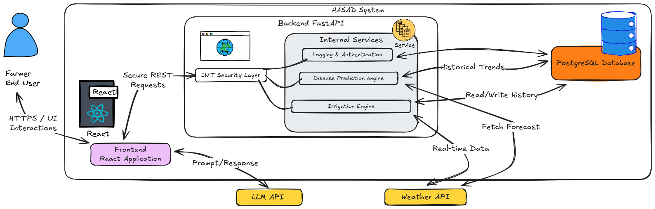
The main parts of the system such as high-level architecture, how users interact with it (use case) and the data model, will be explained in the next part, these diagrams showed how HASAD works to provide reliable features to farmers in a particular way
Figure 3.1: High-Level Structure diagram
The diagram shows how the components of HASAD work. The user will interact with the platform through a React frontend, which uses secure HTTPS connection. All the requests will be sent to the FastAPI backend, that uses JWT for secure authentication and a RESTful API for communication.

The backend is the brain of our system it deals with everything from login to the main services like irrigation math and disease risk analysis. To get the best outcomes, we used services like a weather API for live data and LLM API to give the users smart suggestions. user profiles and farm history, are stored in a PostgreSQL database. We chose this modular design because it keeps the data flow safe and allows the system to scale easily while supporting real-time decisions.

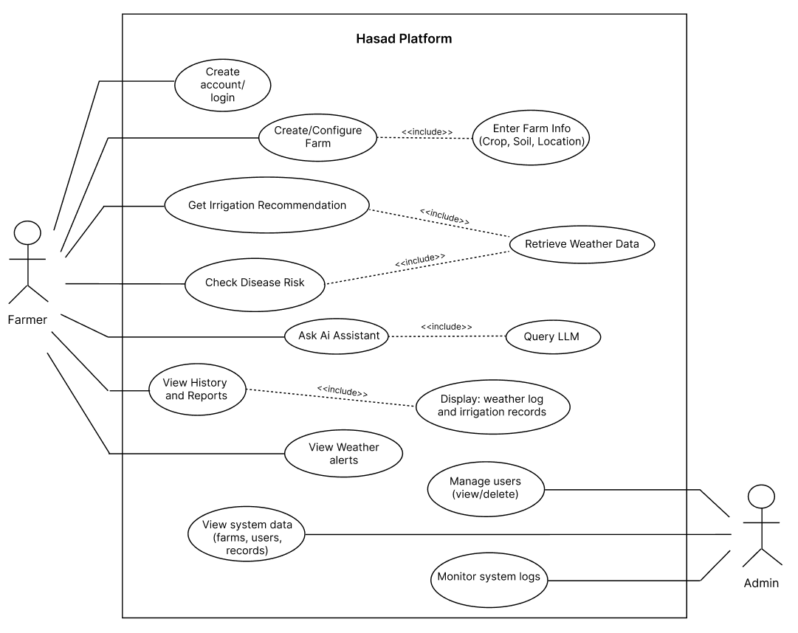Figure 3.2: Use Case diagram
This diagram illustrates how different users interact with the Hasad platform. It identifies two main actors: Farmer and Admin, and the actions they can perform.
- The Farmer can create an account, configure farms, get irrigation recommendations, check disease risk, interact with the AI assistant, and view reports or weather alerts.
- Some actions depend on included processes like retrieving weather data or querying an AI model.
- The Admin has additional privileges such as managing users and monitoring system logs.

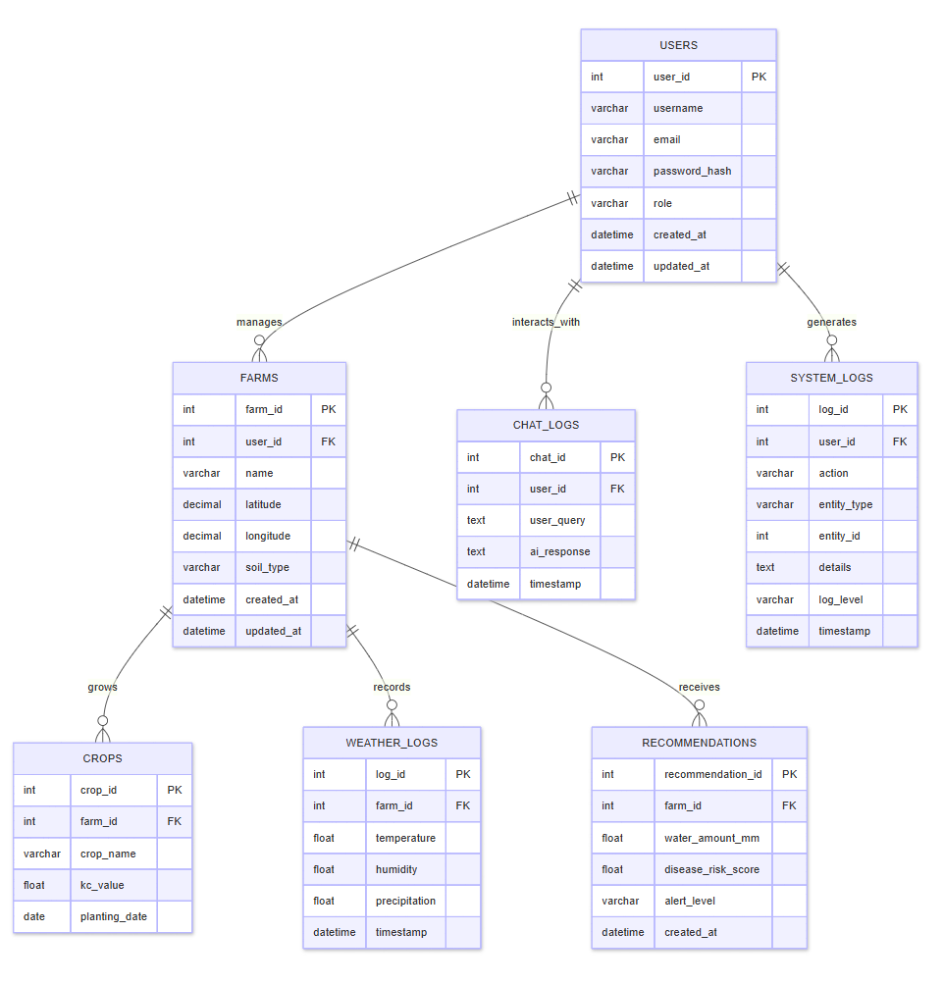Figure 3.3: ER diagram
This diagram represents the database structure of the Hasad platform. It shows the main entities such as Users, Farms, Crops, Weather Logs, Recommendations, Chat Logs, and System Logs, along with their attributes and relationships.
- A User can manage multiple Farms.
- Each Farm can have multiple Crops, Weather Logs, and Recommendations.
- Chat Logs store interactions between users and the AI assistant.
- System Logs track user actions and system events for monitoring.
Overall, it defines how data is organized, stored, and related within the system.

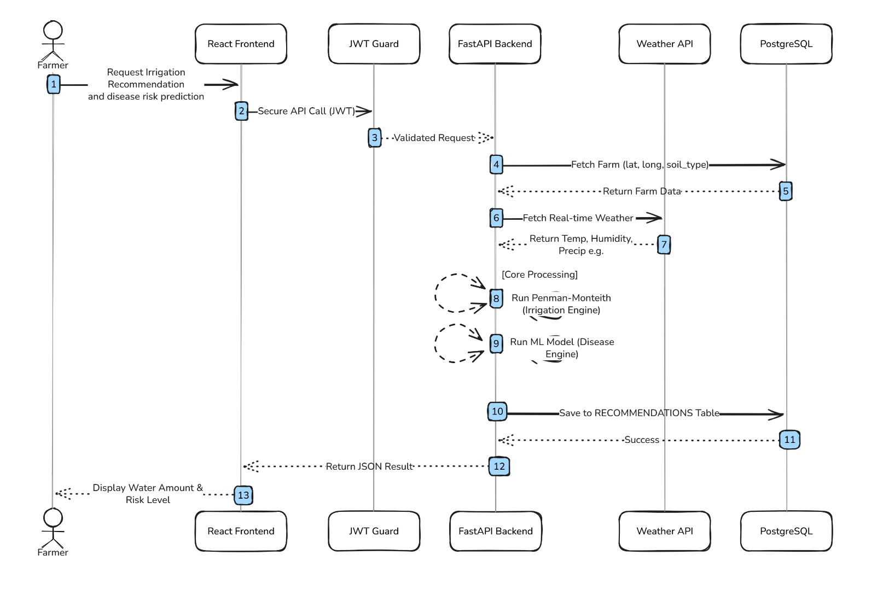
Figure 3.4: Sequence diagram (Irrigation Recommendation and disease risk prediction).
This diagram describes the runtime interactions that generate irrigation recommendations and disease risk predictions, when the user (Farmer) will use the React front-end to submit a request the process will start.
Before the request reaches the FastAPI back-end, it will be checked by JWT the back-end will use the weather API to get the current (Live)weather data and will retrieve data from PostgreSQL database.
This info will be used by the system to tun the disease prediction model and the irrigation calculation engine, the results will be saved in the database, the recommendations will be sent as a structured JSON response to the front-end.
Now the results will be shown to the farmer in a simple dashboard format. This flowchart shows the basic processing logic, external data integration, and secure request management.

  - User Experience and User Interface

HASAD platform's user interface (UI) and user experience (UX) are made to be simple and easy to use, which makes it useful for farmers with limited technical knowledge. Users can access information because of the interface's simple design, understandable language, and basic navigation. The front-end, which is based on React, displays weather information, farm facts and suggestions using a single color palette and clear blocks. Key features are highlighted and user steps are minimized in the login and control panel interfaces. To put it briefly, this user interface makes the platform both efficient and user-friendly by offering strong support for system functionality.

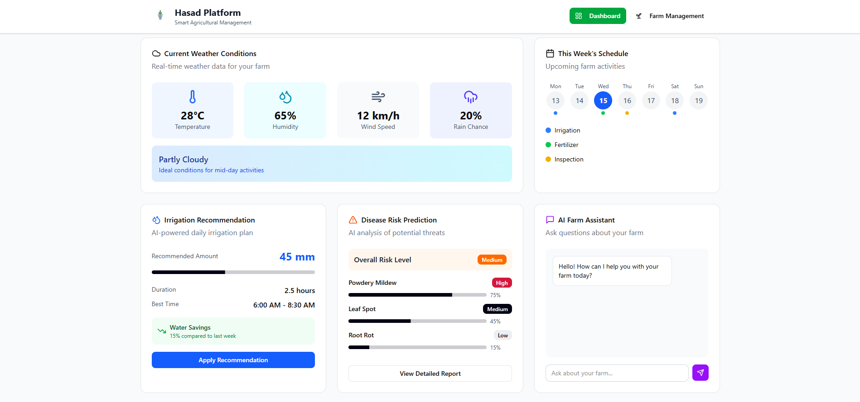
Figure 3.5: SignIn\ SignUp User Interface.
Figure 3.6: Dashboard User Interface.
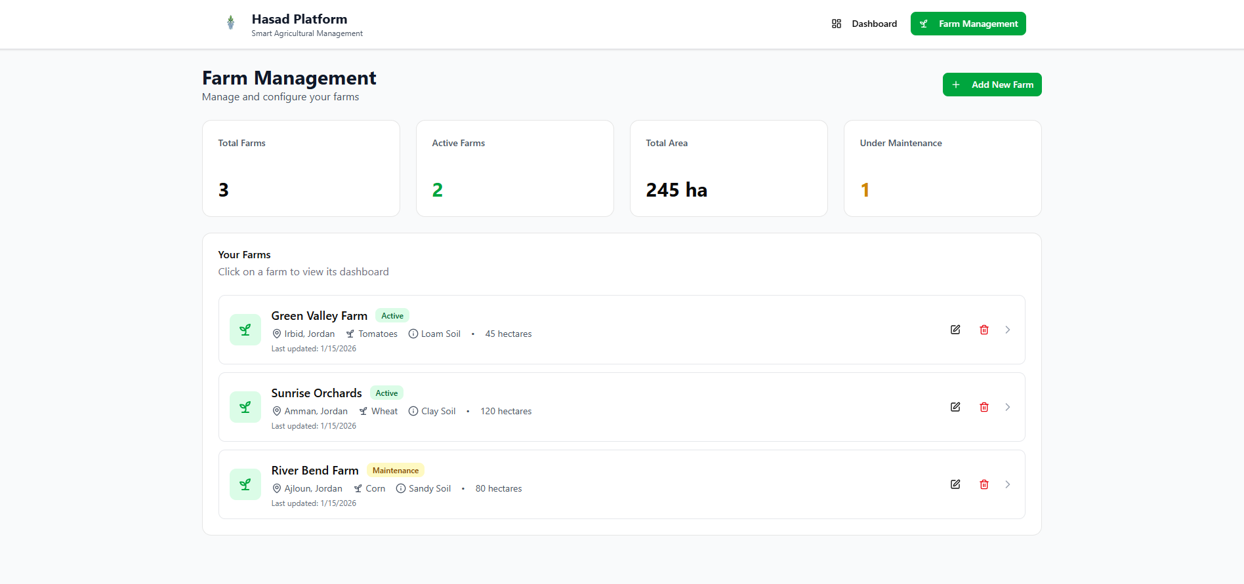
Figure 3.7: Farms Management User Interface.

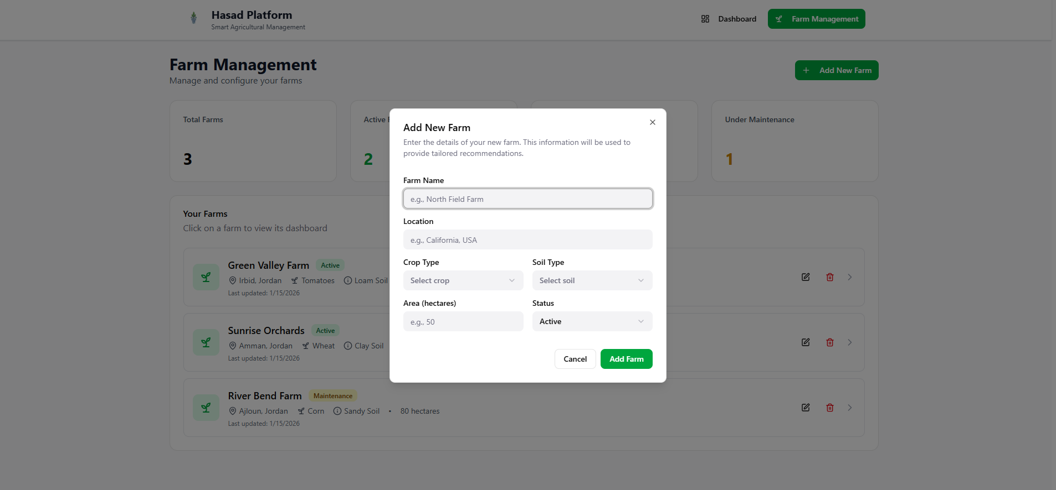
Figure 3.8: Farm Configuration User Interface.

CHAPTER 4
IMPLEMENTATION
This chapter talks about how the HASAD (MVP) was initially implemented. The main goal is to put our first steps on the implementation part . This process is all about making the design as simple as possible without forgetting the most important thing which is meeting key functional and non-functional requirements.
  - System Implementation Overview
- The system implemented to be used for a client server architecture ,we created two interfaces ,we used FastAPI for backend and React for frontend
- We used docker to ensure that the system works in different devices to allow multiple containers to run together with a single file
- All major changes are committed and pushed via GitHub.
  - Backend Implementation
- This sector consists of identity verification and weather data retrieval system which we used a (JWT) token based authentication to protect the interface ; the user identity must be verified to use the service
- It integrates with open weather interface where the user inputs specific farm coordinates to retrieve weather data.
- The backend proccess the data and deals with the JSON file came from the weather API request then response with necessary data such as temperature, humidity, wind speed, air pressure and the location to the frontend.
  - Frontend Implementation
- As we mention before we used React to design the user interface.
- The main page of our interface includes:
- Authentication Page (Login and Sign up)
- Dashboard Page (Weather data visualization)
- We designed interface to display weather data I a clear and easy readability way and In a technical view , we used React to efficiently manage our application state.
- to improve user experience , we saved authentication tokens in the browser, this enables the system to remember the users login.
  - Version Control and Deployment
- We used Git to manage the development process.
- All our files are uploaded to the repository we made GitHub, where we can continuously track changes and maintain a valid copy.
- We use Docker and Docker Compose to ensure the system works in different environments and to allow multiple containers to run together within a single file.
- GitHub Repository: https://github.com/zeidalsuleiman/hasad-mvp

CHAPTER 5
TESTING AND EVALUATION
To ensure the quality of the HASAD system MVP, we focused on testing evaluating one key functional requirement and one non-functional requirement within the project scope with the constraints of the Minimum Valiable Product. And we will also mention our GitHub actions workflows.
  - Functional Requirement Testing
The main functional requirement that has been tested was:
FR-2: The system should retrieve real time weather data based on the farm coordinates ( latitude and longitude ).
Testing was performed by:
- Signing up a new user
- Logging in to the system dashboard
- Entering valid coordinates values ( latitude and longitude )
- Verifying that real time weather data is displayed on the dashboard within the specified coordinates.
The results confirmed that the system successfully accomplish FR-2 that was about retrieving and displaying accurate weather information.
  - Non-Functional Requirement Testing
The main non-functional requirement that has been tested was:
NFR-1: The system should provide a clear and user friendly interface. (and the NFR-3 that was about the Security, but we haven't documented because we are not fully satisfied with it because of the initial implementation constraints.)
This requirement was evaluated by manual testing of the user interface and interaction cards. Weather information was displayed using interactive user friendly well visualized cards with clear labels and icons. The interface remained responsive and visually consistent across multiple interactions.
The results showed that the system satisfies the usability requirement expected for the MVP.
  - Github actions workflows
we performed two GitHub actions workflows at each push operation, one functional and the other is non-functional:

- Functional Workflow:
  - For the functional workflow we used PYTEST for testing, PYTEST is a unit testing, verifying the functional correctness of the backend, ensuring the core functions are working well like authentication, weather data retrieval and more. In other words it verifies security quality.
- Non-Functional Workflow:
  - For non-functional workflow we used BANDIT for security testing, it scans the code itself searches for unfair or unsecured coding practices. So, it basically verifies security behavior.

  - Results and Discussion
The testing results showed that the initial implementation we did had satisfies:
- One functional requirement
- One non-functional requirement
All tested features performed well and satisfies the requirments, and no critical issues were shown during evaluation.
  - Summary
This chapter satisfies and confirms that HASAD system functions correctly meets its core requirements. The successful test results validate the initial implementation requirments and demonstrate that the system is suitable and capable to do.

CHAPTER 6
CONCLUSION
This project focused on designing and building the core stone of our HASAD system. Hasad is a smart farming system that relay on virtual sensing by fetching real time weather data, helping small farmers enhancing their agriculture environments without the need of setting their farms with expensive sensors and IOT devices, using scientific background and ML models to prevent disease risk spreading. The work we have done in graduation project 1 will give us a strong base to start our full implementation in graduation project 2.
  - Key Results
The most important outcomes we achieved are:
- Smart Farm can be possible without expensive sensors and IOT devices.
- By using (real time weather data), (scientific based irrigation engine) and (ML disease risk prediction models):
- Reduce wasted water.
- Help small farmers make better decisions, and enhancing their farms, and crops health.
- Early diseases risk detection.
- Implementing an initial MVP that satisfies one functional and one non-functional requirements, making sure our system is feasible and possible at this stage.
The results showed that our system is ready to jump into the next step.
  - Strengths of the HASAD
Hasad had multiple strength points that are:
- Small farmers solution (low cost)
- No sensors and IOT devices.
- The features and functions combination made it a full smart farming tool.
  - Smart irrigation engine.
  - Disease risk prediction.
  - Agricultural Ai assistant.
- User friendly and easy to use.
That is what made HASAD practically strong.
  - Limitations of HASAD
As an early system putting the first steps on the floor, HASAD may suffer from some risks or limitations:
- External WeatherMap external API may sometimes go down or fail sometimes.
- ML Disease prediction models:
  - Needs more local and global data to have strong predicting accuracy.
  - At the current stage we can't say that we have a strong prediction and diagnosis tool (we are building a strong dataset that will serve this function on graduation project 2).
At the initial MVP implementation stage these limitations are expected, but we will change those limitations to strength points at graduation project 2.
  - Future Work
HASAD vision can be expanded on the future, after making sure that HASAD perform well on graduation project achieving satisfying results in its core functions we mentioned before
These future work can contain several points:
- Adding new spraying and treatment recommendations engine
- Building a mobile app.
- Adding multiple languages expanding our users globally.
Note that these upgrades are just an expanding vision, we are not giving any promises with them.
  - Summary
In conclusion HASAD had achieved and proves that software based smart farming is possible. The system solved two of the biggest agriculture problems that Jordan have been facing from the waste of resources (water), and late disease prediction and prevention. We successfully have delivered a complete analysis, design, initial implementation. We put a strong foundation for graduation project 2, where HASAD can grow into a full completed smart farming system.

References

- R. G. Allen, L. S. Pereira, D. Raes, and M. Smith, "Crop evapotranspiration - Guidelines for computing crop water requirements - FAO Irrigation and drainage paper 56," FAO, Rome, vol. 300, no. 9, 1998.
- P. Paredes, G. D’Agostino, L. S. Pereira, et al., "Soil water balance models for determining crop water requirements and scheduling irrigation," Agricultural Water Management, vol. 241, p. 106357, 2020.
- L. Breman, "Random Forests," Machine Learning, vol. 45, no. 1, pp. 5–32, 2001.
- P. Lewis et al., "Retrieval-Augmented Generation for Knowledge-Intensive NLP Tasks," Advances in Neural Information Processing Systems (NeurIPS), vol. 33, 2020.
- M. S. Metagar, A. G. Walikar, and A. G. Walikar, "Machine Learning Models for Plant Disease Prediction and Detection: A Review," Agricultural Science Digest, vol. 44, no. 4, pp. 591-602, 2024.
- National Agricultural Research Center (NARC), "WAFIRR: Smart Irrigation Support for Jordan," [Online], 2023.
- PEAT GmbH, "Plantix: The Digital Plant Doctor," [Online]. Available: https://plantix.net.
- Food and Agriculture Organization (FAO), "Irri-Smart: Decision Support System for Irrigation," [Online], 2022.
- Farmonaut, "Satellite-Based Crop Monitoring and Precision Agriculture," [Online]. Available: https://farmonaut.com.
- National Field Crops Institute (INGC), "IREY: Irrigation Reference to Enhance Yield Portal," Tunisia, 2023.

APPENDIX

Meeting Minutes

Date | Attendees | Summary of Previous Tasks | Achievements | New Problems | Planned Tasks
Oct/  28/ 2025 | Mohannad, Hakem, Zeid, Khattab. |  | identifying the scope and core functionality of the project. | Figuring out the software solutions. | A clear problem statement and project definition.
Nov/  7/ 2025 | Mohannad, Hakem, Zeid, Khattab. | A clear project abstract. | Chapter one is done with a clear problem definition and core functions. | Need to find a mathematical model to replace enable virtual sensing. | Theoretical background and gathering related works.
Nov/  14/ 2025 | Mohannad, Hakem, Zeid, Khattab. | Start searching and working with literature work. | Confirmed feasibility of using OpenWeather API with FAO-56 for irrigation. | Many similarities of related system | Define Functional FR and Non-Functional Requirements NFR.
Nov/  28/ 2025 | Mohannad, Hakem, Zeid, Khattab. | Summarized related works and  Defined FRs and NFRs. | Chapter 2 is done and finalized requirement analysis | Determining the technology stack. | Design System Architecture, ER Diagrams, and Use Case Diagrams.
Dec/  1/ 2025 | Mohannad, Hakem, Zeid, Khattab. | Designing the diagrams | A clear technology stack and use case diagram is done. | Finding a tech stack that will perform well | Approving the tech stack and starting building the repo.
Dec/  15/ 2025 | Mohannad, Hakem, Zeid, Khattab. | MVP is sited up and working on. | Putting our first steps on the CI/CD pipeline | Building docker imgs, and composing them. | Begin Backend  And Frontend implementation.
Jan/  11/ 2025 | Mohannad, Hakem, Zeid, Khattab,  Abd | MVP is fully ready, and docker environment is set | Connected React Frontend to FastAPI Backend. | Connecting endpoints.  And local hosts | Finalizing the report and formatting it.
Jan/  18/ 2025 | Mohannad, Hakem, Zeid, Abd | Finalizing the report and formatting it. | MVP Finalized. All tests passed, final Report chapters 4, 5, and 6. And final formatting. | Preparing for the final presentation. | Print final report, design the poster, and rehearse presentation.

